File bzone_network_design.csv
April 24, 2026

Definition of the Input File
VisionEval (https://visioneval.github.io/docs/model-inputs.html) explains that this file “contains values for D3bpo4, a measure for intersection density determined by the number of pedestrian-oriented intersections having four or more legs per square mile” which can be obtained from the Smart Location Database. These values are shown below for three bzones: 515400010001 (an urban area near Charlottesville’s downtown pedestrian mall) with large amounts of employment, 510030107021 (a suburban area near Route 29 in Albemarle County with some employment), and 510030110004 (a rural residential area in Albemarle County). Not surprisingly, the largest density of pedestrian-friendly intersections is in the most urban zone with the most rural bzone having the lowest value of 0.51.
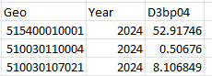
For year 2045, values are presumed to be the same as for year 2024.
Possible Scenario
Urban design can influence travel behavior. As noted in the document Task 7.2 Simplified Scenario Development guide, available at A Playbook for Simplified Approaches for Creating Scenarios in VisionEval, two related files—bzone_network_design.csv (this one) and bzone_urban-mixed-use_prop.csv can help one determine how walkable a given location is to other locations (e.g., New York City has values of 200-300). Further, one can see how changes in this value affect the number of walking trips (and with the multimodal module, the number of walking pedestrian miles traveled).
Method Used for Virginia
The EPA’s Smart Location Database (https://www.epa.gov/smartgrowth/smart-location-mapping#SLD) measures location efficiency using many characteristics including D3bpo4, which is an Urban Design (D3) variable. The data for D3bpo4 comes from 2018 HERE Maps NAVSTREETS, a road network database, as well as Census Block Groups as defined in the 2019 Census TIGER/Line databases, shown in the file EPA_SLD_Database_V3_2021. The values for D3bpo4 in Virginia bzones range from 0 to 450.448. Appendix A gives instructions for downloading these data if needed. There is one additional processing step which is also given in Appendix A, where the summarize within was used. An alternative that would be acceptable would be spatial join, but in this case summarize within may be more accurate.

Appendix A. Downloading EPA Smart Location Database Data
- Which Data to Download from the EPA Website: Download data for all areas with coverage 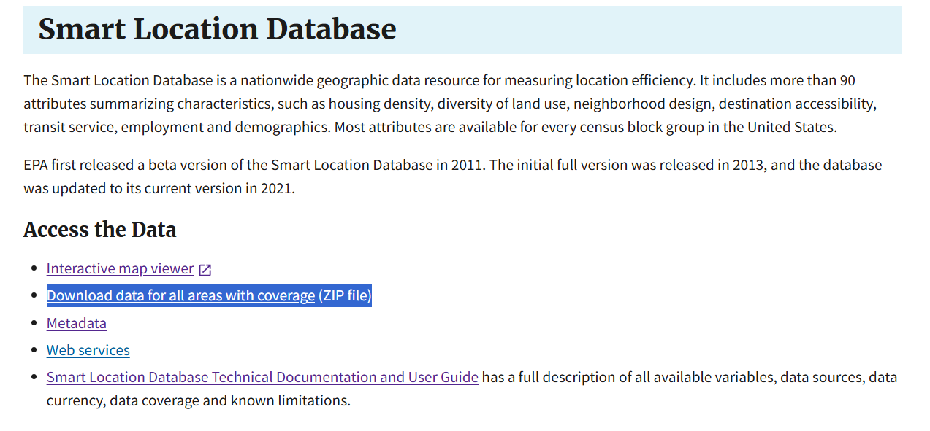
- How to process the D3 data
  - Open ArcGIS Pro and create a new project by selecting “Map.” Browse to the “SmartLocationDatabaseV3” folder that contains “SmartLocationDatabase.gdb,” then click OK to create the project. 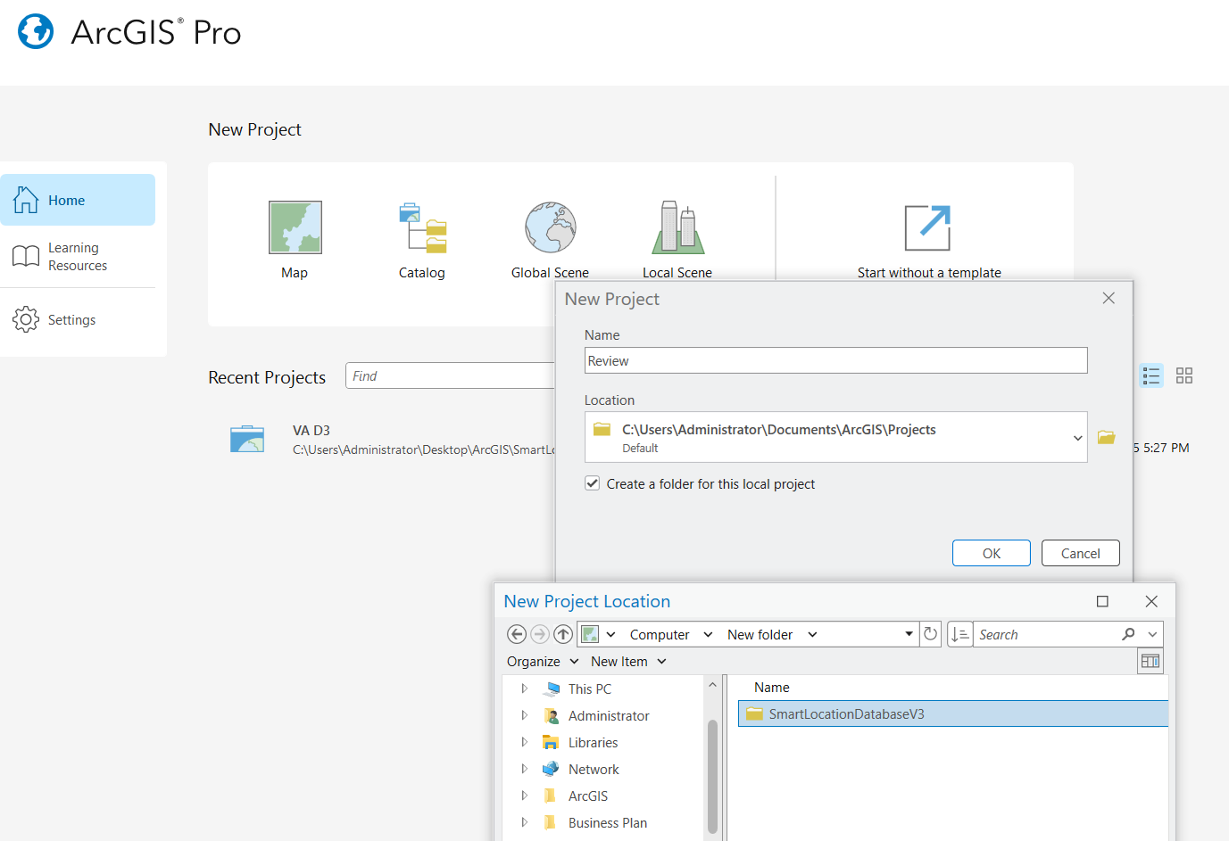
  - Folder Connection
    - In the Catalog pane on the right side of the screen, right-click on Folders and select Add Folder Connection.
    - Browse to the SmartLocationDatabaseV3 folder and click OK.
    - The folder will then appear under the Folders section. 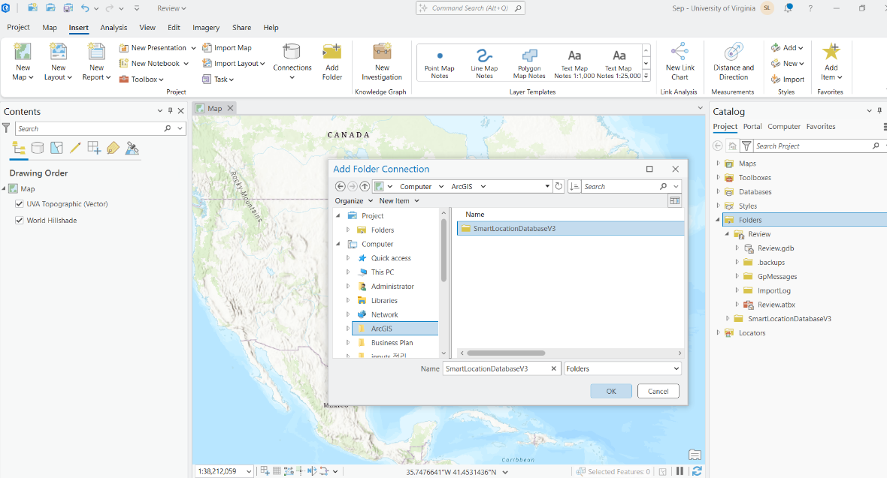
  - Load the data into the project: Drag “EPA_SLD_Database_V3” file from the Catalog pane into the center Map view 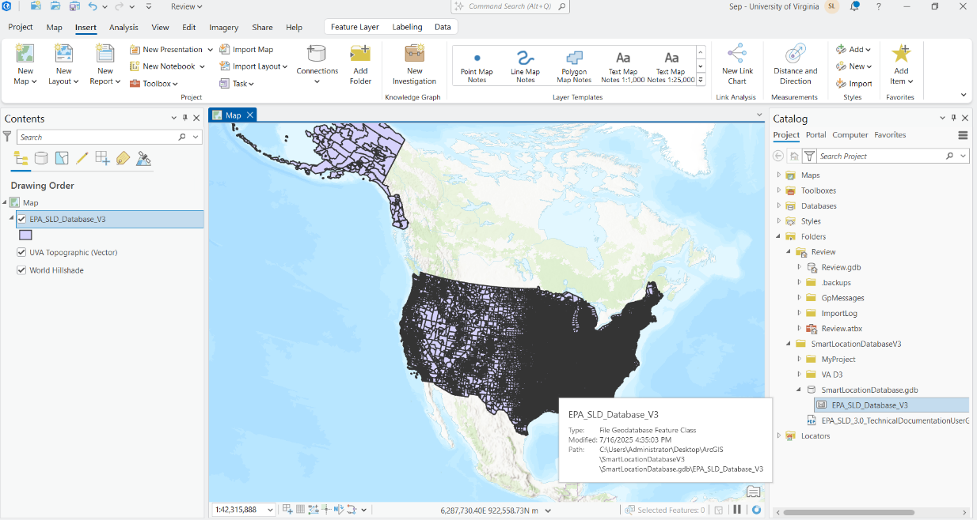
  - In the Contents pane on the left, right-click the selected layer, go to Data > Export Features. 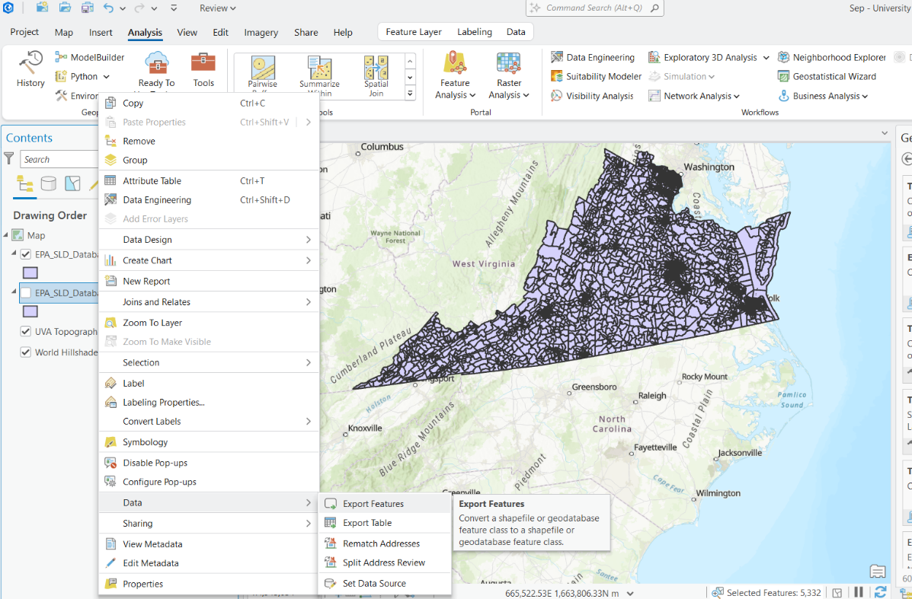
  - To filter for Virginia only: Go to the Map tab, click Select by Attributes, then select the field State Code FIPS. Type 51 (the FIPS code for Virginia), and click Apply. 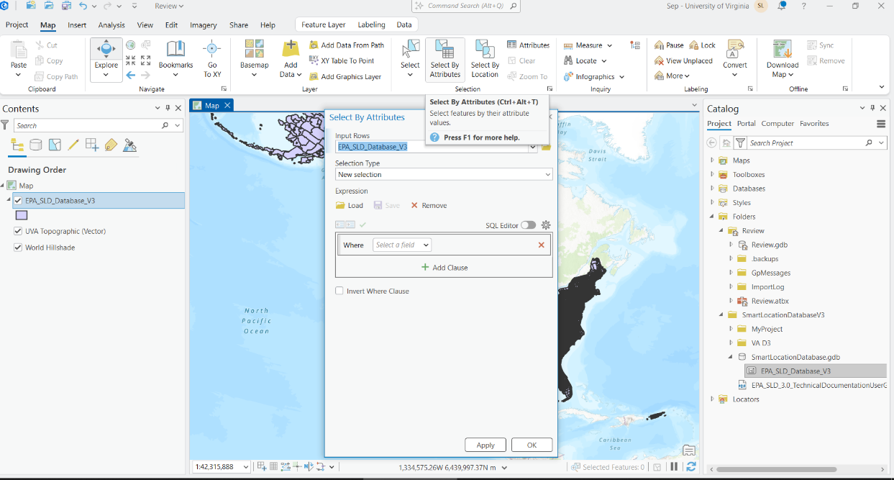
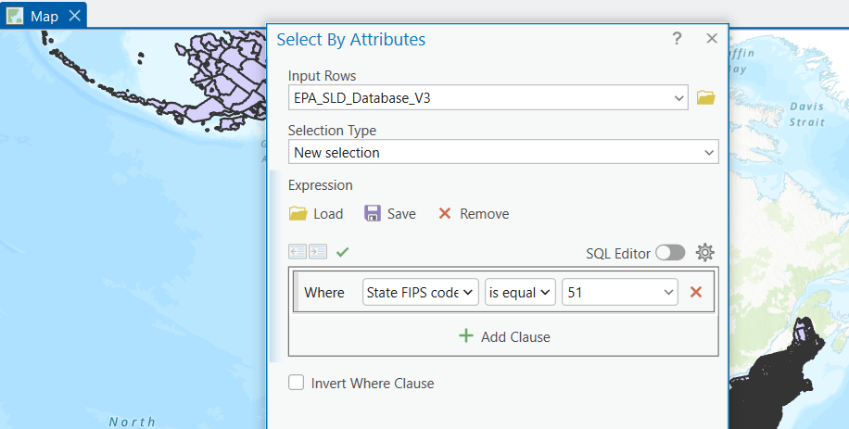
  - Note—There is a slight difference zones between those used for Virginia in 2024 and those available from the older Smart Growth Database. Accordingly, either a spatial join or summarize within may be used; I believe the summarize within is more accurate.
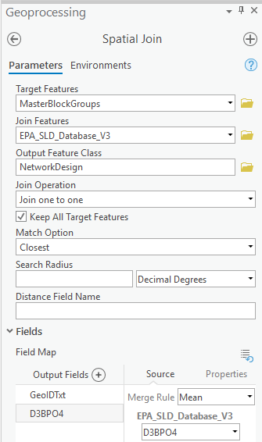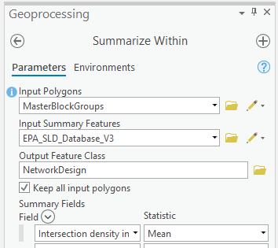

  - To export only the Virginia data to CSV format: Right-click the layer in the Contents pane and open the Attribute Table. Click the menu button in the upper-right corner of the table and select Export. Choose the destination folder and enter a file name with a .csv extension. After exporting, you may either filter the table to include only the GeoID and D3bpo4 fields, or remove all other fields before saving. 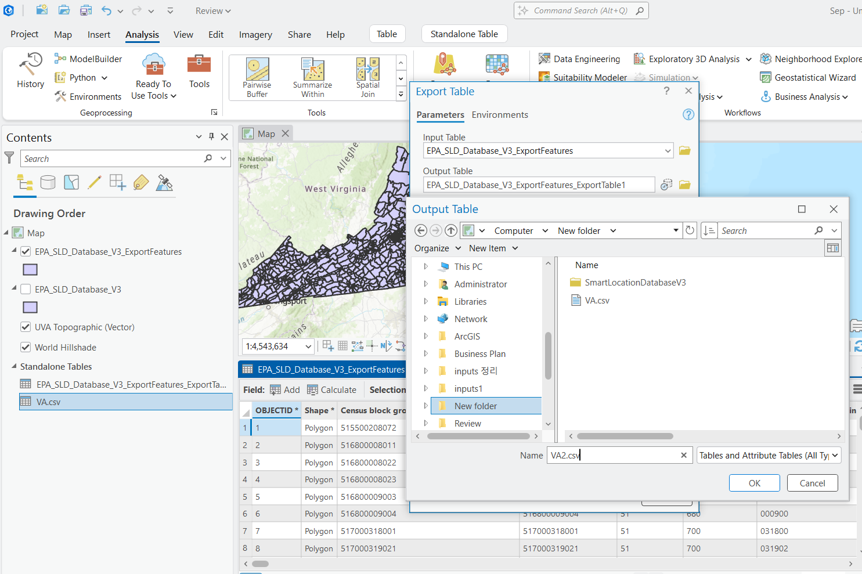
  - Result 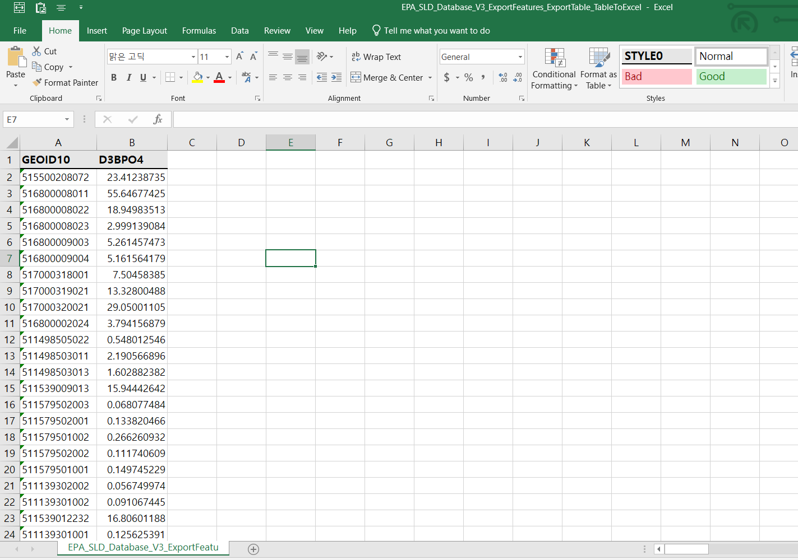

SCRAP
In general, there are three places to look for how to figure out what these attributes mean:
      - The link https://visioneval.github.io/docs/model-inputs.html#verspm-inputs has a definition for each CSV file

      - The document Task 7.2 Simplified Scenario Development guide is available at this link: A Playbook for Simplified Approaches for Creating Scenarios in VisionEval

      - The old VTRC report—which used an older version of VisionEval a while back, is https://vtrc.virginia.gov/media/vtrc/vtrc-pdf/vtrc-pdf/22-R21.pdf

      - Also, John has the Smart Location Database at D:\VE2025\BlockGroupsBZones\Align and \\501-RC-NAS1\Users\John.Miller\LT\Team_Projects\VE_STudio\Bzone_Transit_Service.docx

EPA Smart Location Database is on John’s Machine
- D:\VE2025\BlockGroupsBZones\Align has the files

- EPA_SLD_3.0_TechnicalDocumentationUserGuide_May2021.pdf shows D3bp04
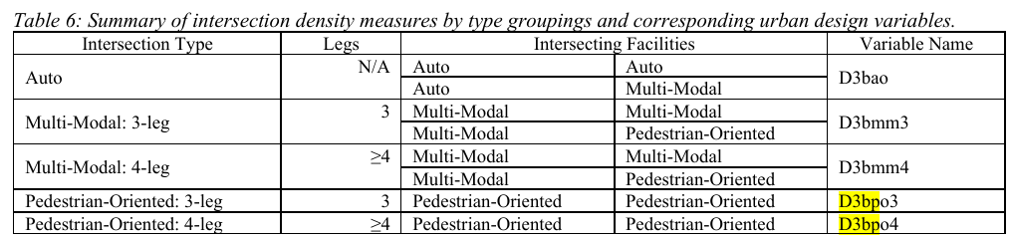
- Here is the GIS File on my machine:

- The document Task 7.2 Simplified Scenario Development guide is available at this link: A Playbook for Simplified Approaches for Creating Scenarios in VisionEval

- Here is the screenshot for that task

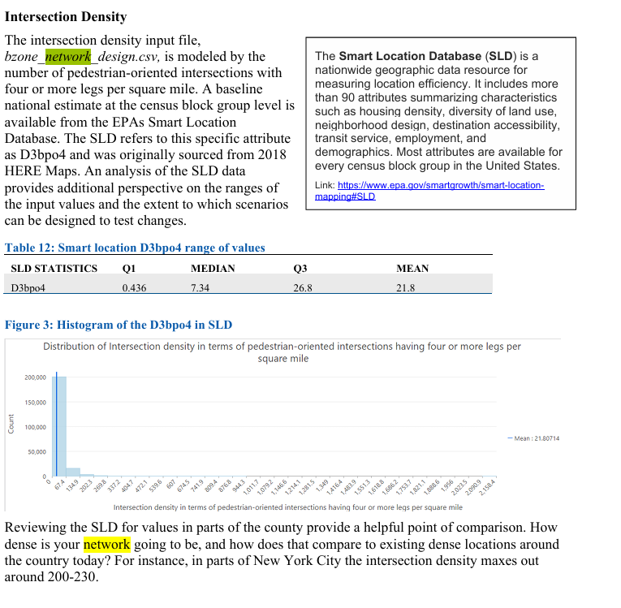
What we should be thinking about next:

- Let’s number the input files (1-53 or so)—perhaps Sep should do this since he keeps good track.
- When doing an input file check for three items
  - Guidance on the VE site
  - VTRC report
  - Simplfied playbook
- Writeups
  - Provide a summary at the top of what the attribute means and give one example
  - Separate 2024 and 2045
- Rationale for doing a forecast
  - The trend might be that 2045 will be different from 2024 (e.g., housing—we will grow). Alternatively, trend might be 2045 is same as 2024 (e.g., no guarantee of ped-friendly int)
  - To resolve identify at least one policy scenario that could result from changing 2045 for the variable of interest

